# **5.0 MySQL Configuration**

## **5.1 SETUP**

MySQL is an RDBMS (relational database management system) using SQL language to manage and operate databases. Here are the steps to install MySQL on OpenSUSE Leap VM.

**Step 1:** Open your VM, and search for Konsole to start your installation (ALT+F2 to open the search box)

*Figure 1: Search for Konsole*

**Step 2:** First you need to update system packages to ensure the system packages are up to date. Enter two commands, ‘sudo zypper refresh’ and ‘sudo zypper update’.

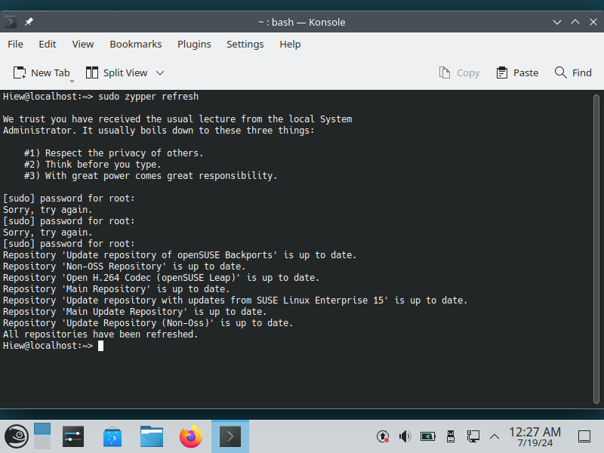

*Figure 2: Refresh the system packages using the command ‘sudo zypper refresh’*

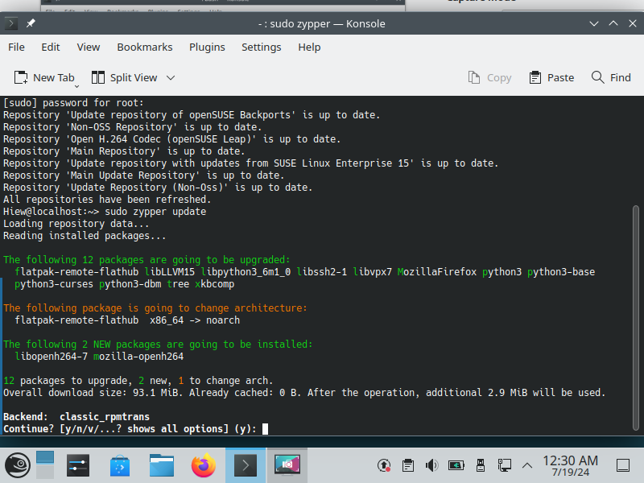

*Figure 3: Using the command ‘sudo zypper update’, enter y to continue*

**Step 3:** Now you can install MySQL, use the zypper package manager to install MySQL. Using the command ‘sudo zypper install MySQL MySQL-server’.

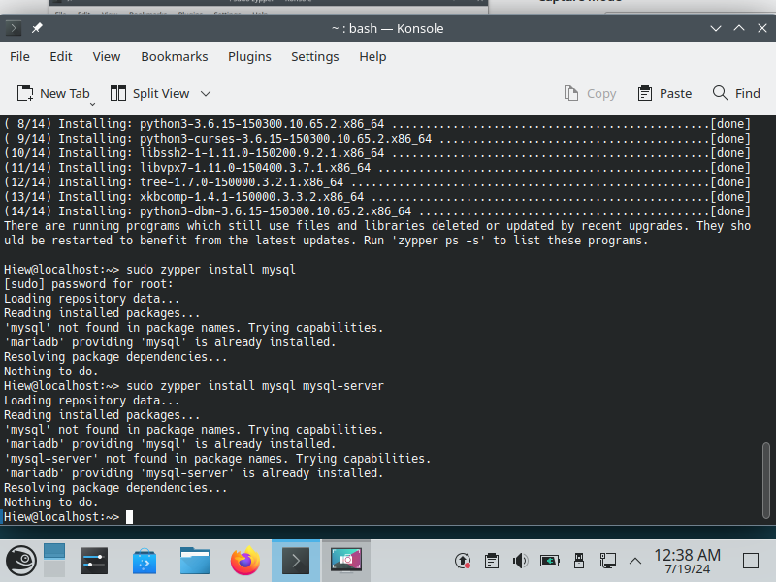

*Figure 4: Some OpenSUSE Leap may have the MariaDB which is already provides MySQL and MySQL server, so it doesn’t need to install (if not using the command to install)*

**Step 4:** Start the MySQL service using the command ‘sudo systemctl start mysql’. After that use the command ‘sudo systemctl enable mysql’ to enable it to start at boot (if want).

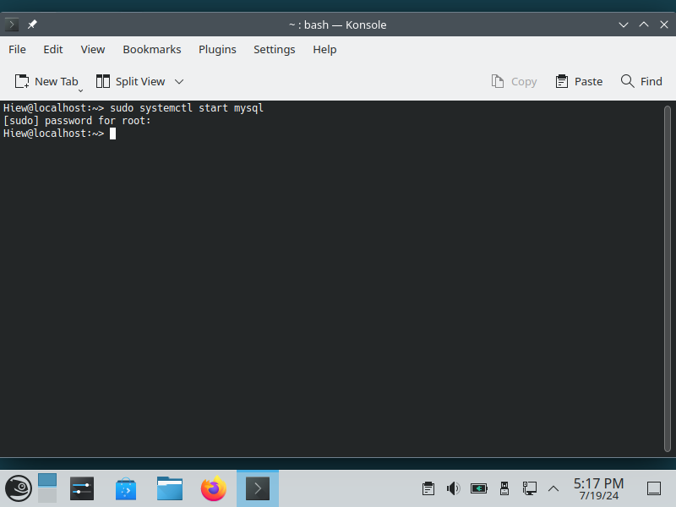

*Figure 5: Using the command ‘sudo systemctl start mysql’ to start MySQL*

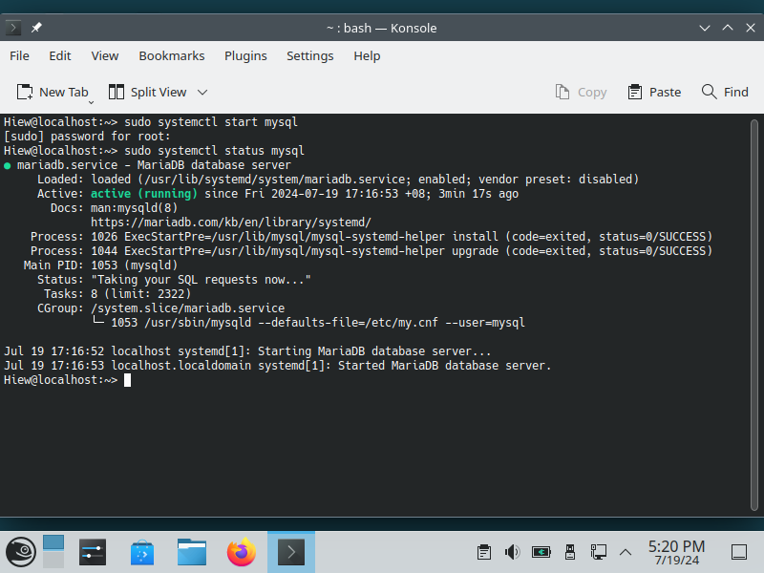

*Figure 6: Notice here, that after starting MySQL and entering the password but no reaction, use the command ‘sudo systemctl status mysql’ to check the status of mysql*

**Step 5:** Using the command ‘sudo mysql_secure_installation’ to secure your MySQL installation, follow the steps to set up your MySQL databases.

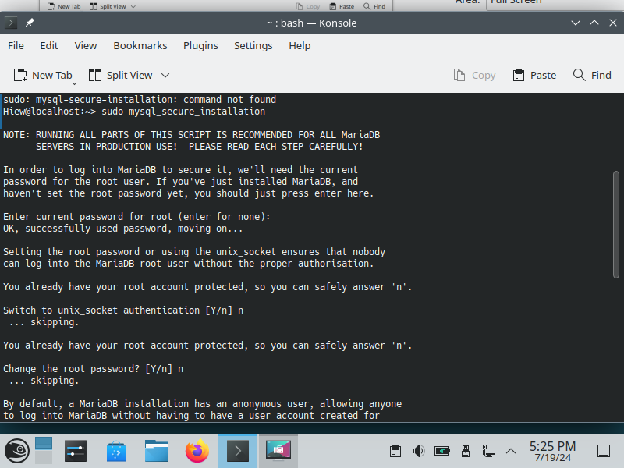

*Figure 7*

*Figure 8*

**Step 6:** Finally, you can access your MySQL now! Use the command ‘sudo mysql -u root -p’ to access your MySQL database.

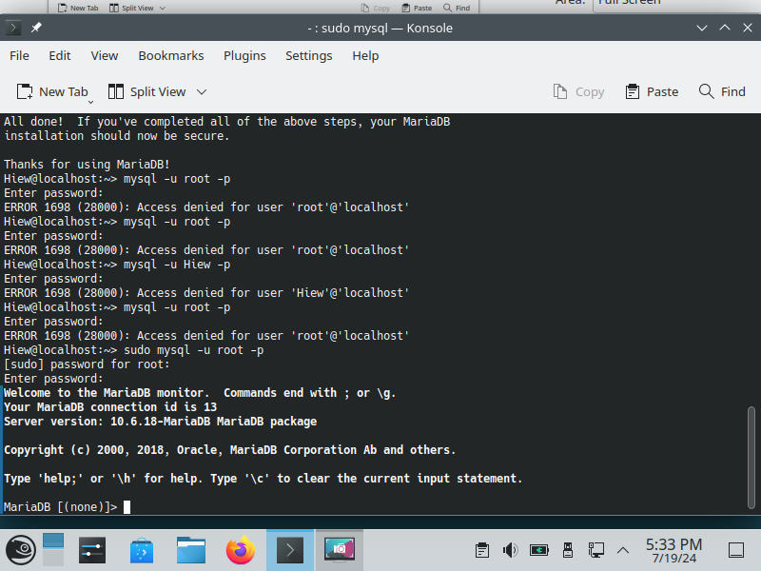

*Figure 9: Using the command ‘sudo mysql -u root -p’ access MySQL, enter the password of your VM (if no change while step 5) to access it.*

## 

## **5.2 OPERATION IN MYSQL DATABASES**

**Command:** Create table.

**Command:** Insert Data into the table.

**Command:** Search for the data of the table.

**Command:** Update the data in the EMP table.

**Command:** Delete data from the EMP table.

